1.4.1 Vietnam War
Primary Source Analysis
Section I
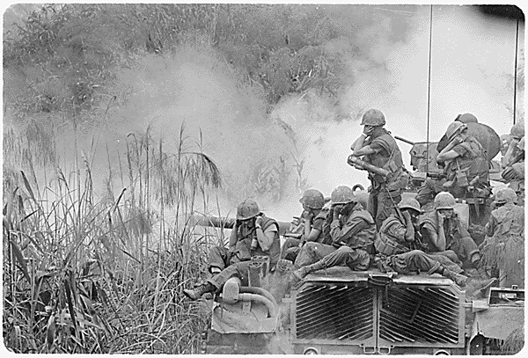
Marines Riding on an M-48 Tank

Study this image. Then, fill in the chart with what you observe. Then, answer the analysis questions.
People

Objects

Actions

- What can you infer from the photograph?

- What questions does this photograph raise in your mind? (“none” is not an acceptable answer)

- How might you categorize this photograph? (examples: battle tactics, weapons, tanks, or jungle warfare.

- Create a caption for the photograph.

- Give an example of how today’s lecture helped you understand this image.

Section II
Next, choose 2 images from the following list, and answer the same questions as above. (You can copy and paste the questions here to make this easier) Make sure to tell us which image goes with which answers.

Operation "Yellowstone" Vietnam
Operation "Oregon"
A Sky Trooper
Soldiers Carry A Wounded Comrade
Marines of Company H
Wet Going
A Marine Stands Watch
Home is Where You Dig
Republic of Vietnam
South Vietnam
Navy Nurses
South China Sea

Section III : Short Answer
Answer the following question in a paragraph, using at least 3 examples from the lecture, and 3 examples from the images.
- How was American society in the 1950’s and 60’s impacted by the Vietnam War?

Section IV:
Use complete sentences to explain the following Presidents’ actions regarding Vietnam
- Dwight Eisenhower (1953-1961)

- John F. Kennedy (1961-1963)

- Lyndon B. Johnson (1963-1969)

